Learn about Science and Art…While Earning a Gift Certificate!
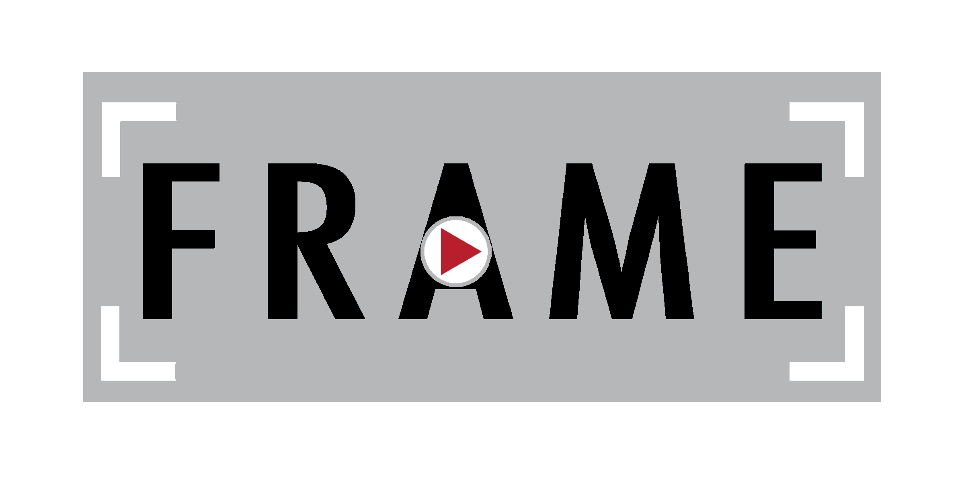
F.R.A.M.E Workshop: Beacon
(Film – Radio – Art – Media – Entrepreneurship)
6 weeks, three days a week Jan. 30th – March 8th, Tues/Weds/Thurs
3:30-5:30 pm each day For youth ages 10 – 14

Name: ___________________________________Grade:__________________________________

Address:_________________________________________________________________________

Zipcode:_______________________School:___________________________________________

Phone: ________________Email: ____________________________________________________

Parent/Guardian Contact Info (if different from above): __________________________________

________________________________________________________________________________

Describe a time you worked really hard at meeting a goal. What was the goal, and what did you do to make sure you met it?

________________________________________________________________________________
________________________________________________________________________________
________________________________________________________________________________
________________________________________________________________________________

________________________________________________________________________________

________________________________________________________________________________
________________________________________________________________________________
________________________________________________________________________________
Describe the best piece of art you have ever created. Explain what it is, how you made it, and why you consider it to be the “best.”
________________________________________________________________________________
________________________________________________________________________________
________________________________________________________________________________
________________________________________________________________________________

________________________________________________________________________________

________________________________________________________________________________
________________________________________________________________________________
________________________________________________________________________________
Which do you prefer: questions with a single, specific answer, or open-ended questions where there are no answers? Why?
________________________________________________________________________________
________________________________________________________________________________
________________________________________________________________________________
________________________________________________________________________________

________________________________________________________________________________

________________________________________________________________________________
________________________________________________________________________________
________________________________________________________________________________

